



**CSU Sacramento**

**Department of Electrical Engineering**

**Lab 6: Active Low Pass Filters**

**Sam Lee**

**Partners: Jordan Moore, Jeffrey Hawthorn, Awfa Al-Rakabi**

**EEE 117L Network Analysis Laboratory**

**April 19th, 2019**

**Professor Sergio Aguilar Rudametkin**

**Section: 01**

**Day: Monday**

**Time: 5pm-7:40pm**

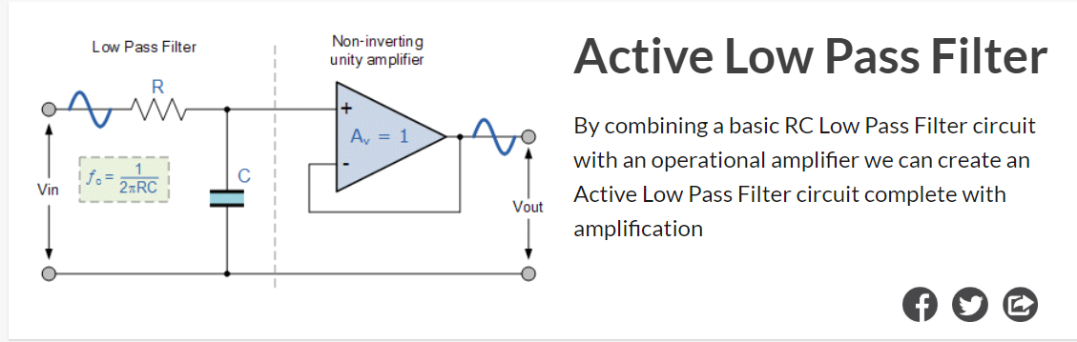

**Introduction:**

This lab was an introduction to low pass filters. A low pass filter is a circuit that can be designed to modify, reshape or reject all unwanted high frequencies of an electrical signal and accept or pass only those signals wanted by the circuit designer. The low pass filter only allows low frequency signals from 0Hz to its cut-off frequency, ƒc point to pass while blocking those any higher. A simple passive low pass filter can be easily made by connecting in series a single Resistor with a single Capacitor as shown below. In this type of filter arrangement, the input signal (Vin) is applied to the series combination (both the Resistor and Capacitor together) but the output signal (Vout) is taken across the capacitor only.

**Purpose:**

The purpose of the Part I of this experiment is to consider the sinusoidal response of several first order filters. The effect of loading (applying a load resistor to the output of the circuit) on the frequency response will be investigated. Part II of the experiment will consider the use of Fourier Series in circuit analysis.

**Discussion and Results:**

**Part 1: Sinusoidal Steady State Frequency Response**

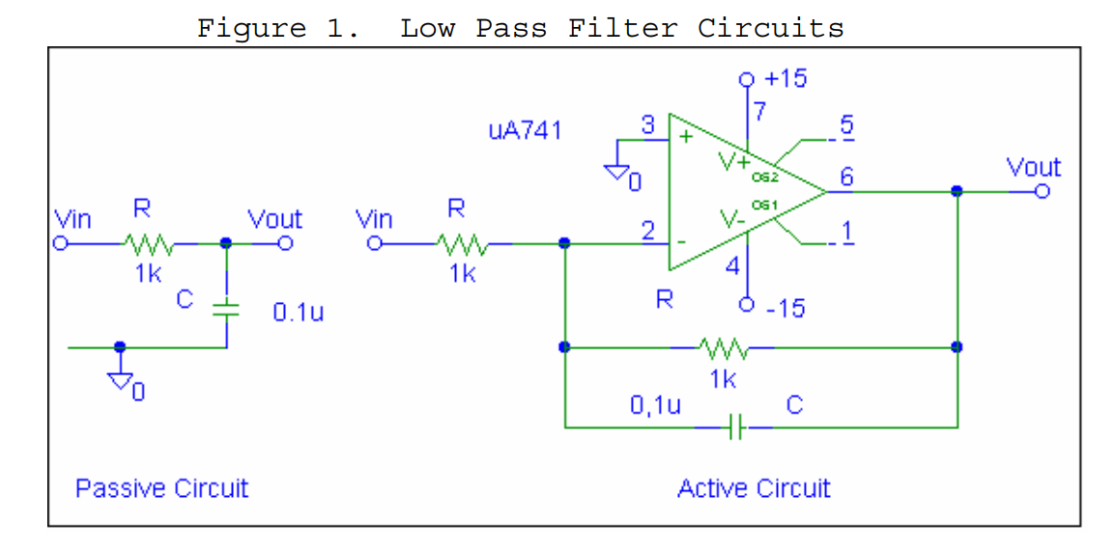

We began this lab by first physically designing the schematic shown in Figure 1 on our bread board. An example of the Active circuit is shown below:

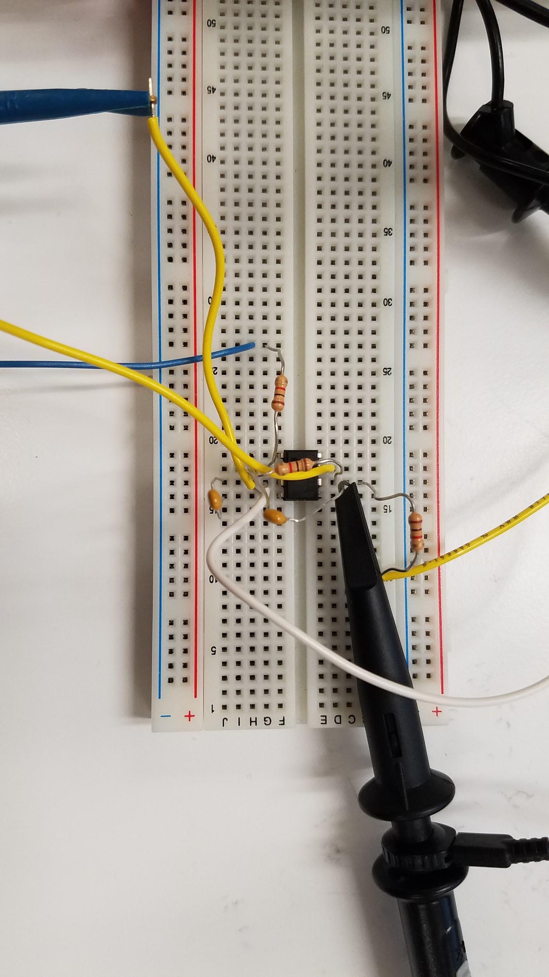

We then measured the low frequency (about 100Hz) gain and phase shift at the output for a sinusoidal input for both circuits. These values are displayed in **Table 1** below:

|  |  |  |
| --- | --- | --- |
| **Table 1: Gain and Phase Shift for circuits at 100Hz and 2Vpp** | | |
|  | **Passive Circuit** | **Active Circuit** |
| **Vin (V)** | 2.07 | 2.03 |
| **Vout (V)** | 1.41 | 1.43 |
| **Phase Shift (Degrees)** | 50 ~ 45 | 45 |
| **3db Point (kHz)** | 1.9 | 1.7 |

We then added a 1k Ohm resistor to the output and measured the same values as shown in **Table 2** below:

|  |  |  |
| --- | --- | --- |
| **Table 2: Gain and Phase Shift for circuits with 1k resistor at 100Hz and 2Vpp** | | |
|  | **Passive Circuit** | **Active Circuit** |
| **Vin (V)** | 2.05 | 2.03 |
| **Vout (V)** | 0.72 | 1.43 |
| **Phase Shift (Degrees)** | -50 ~ 45 | 135 ~ 45 |
| **3db Point (kHz)** | 1.9 | 1.7 |

Our generated waveforms are shown:

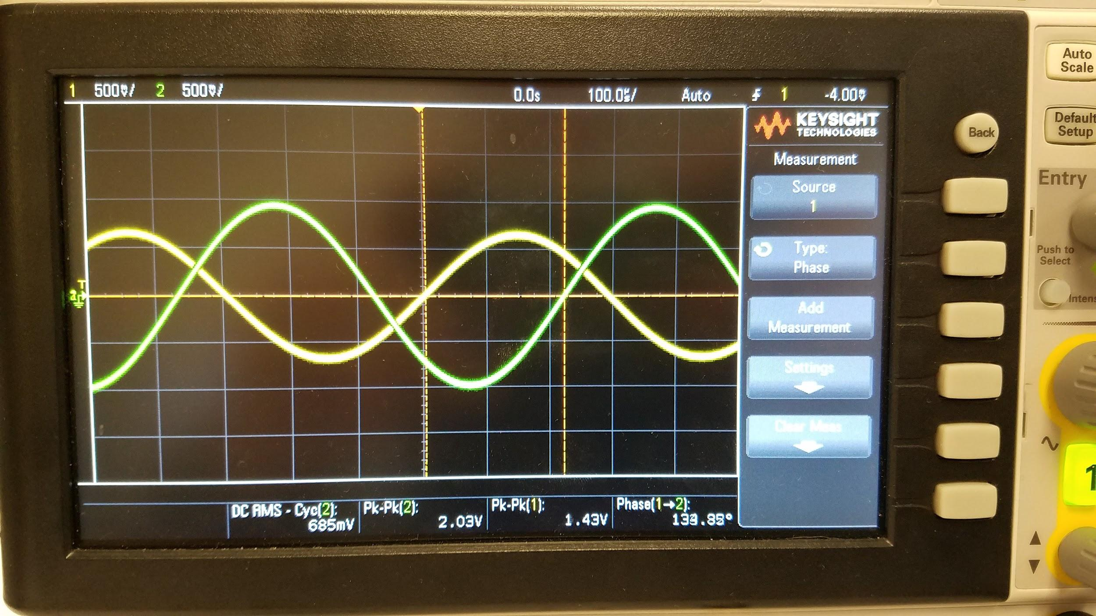

*Figure 2: Waveform of Active Circuit with 1k Ohm Resistor*

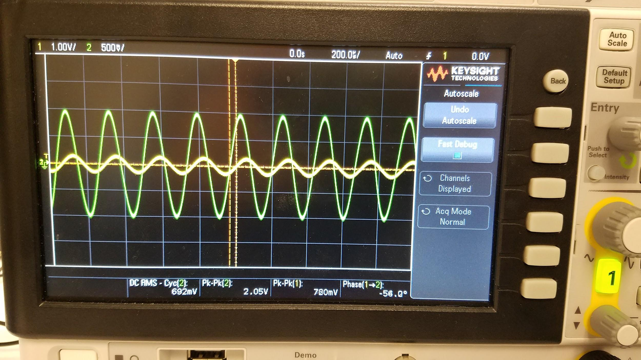

*Figure 3: Waveform of Passive Circuit with 1k Ohm Resistor*

**Conclusion:**

In this lab, we were able to consider the sinusoidal response of several first order filters that we designed both on the breadboard. We also tested the various effects of loading, with a load resistor of 1k Ohms to the output of the circuit and investigated the effects on the frequency response.